|  |
| --- |
| 41-550 Monetary Theory |
| Take Home Exam 3 |
| Professor Jay Rhee |

|  |
| --- |
| Sumair Khoja – 104471153  Matthew Dennahower - 103728472  4-7-2017 |

**Question 1)**

**Description of the Model:**

This model considers the New Keynesian Phillips curve looking at the change in inflation based on change in deviation in the output value from its natural rate as well as the expected rate of inflation in the next period. It takes into account a technological shock in the model as well as the shock in the money supply by the Central bank. The model run below considers a monetary shock in the system and how this shock will affect the level of output, its deviation from the natural rate, the natural rate of output itself, along with the real interest rate and the nominal interest rate and the real and nominal money balances. It also considers the expected level of inflation along with the expected level of output deviation and how a monetary shock would impact these values over time given a set of parameters placed on these values.

**Code of the Model:**

// Endogenous Variables

var y pi yt yn a rn l i chngm;

// Exogenous Variables

varexo ea em;

// Parameters

parameters beta K psi rhoa sigma rhom lambda alpha phi theta bigt epsilon ac ai sigmaa sigmam;

// Calibration

alpha = 0.33;

beta = 0.99;

sigma = 1;

phi = 1;

epsilon = 6;

theta = 0.75;

//theta = 0.0001 To consider the different cases for theta

//theta = 0.99 To consider the different cases for theta

ai = 0.5;

ac = 1;

rhoa = 0.95;

rhom = 0.5;

sigmaa = 0.75;

sigmam = 0.25;

bigt = (1-alpha)/(1-alpha+alpha*epsilon);

psi = (1+phi)/(sigma*(1-alpha)+alpha+phi);

lambda = (1-theta)*(1-beta*theta)*bigt/theta;

K = lambda*(sigma + (alpha+phi)/(1-alpha));

//Equations

model;

pi = beta*pi(+1) + K*y;

y = yt - yn;

yn = psi*a;

a = rhoa*a(-1)+ea;

y = y(+1) - (sigma^(-1))*(i - pi(+1)- rn);

rn = -1*sigma*psi*(1-rhoa)*a;

l = ac*y + ac*yn - ai*i;

l = l(-1)+chngm-pi;

chngm = rhom*chngm(-1)+em;

end;

// Steady State

steady;

// Blanchard-Kahn conditions

check;

// Perturbation analysis

shocks;

var em; stderr sigmam;

end;

// Stochastic simulation

stoch_simul (order=1, irf=100, periods = 250);

**Impulse Response Functions:**

Theta = 0.75



A shock in the money supply triggers a shock in multiple variables. Firstly, the expected level of the change in money supply increases by value of approximately 0.2 in the first period of when the shock occurs. However, this is only a temporary shock and as expectations do not change, the level of the change in the money supply returns to its original steady state. Similarly, there is a positive shift in the nominal interest rate in the first period and it also reaches the steady state at zero. The demand for real money balance also experiences a positive shock. However, unlike the previous variables, this variable increases for a few periods to reach its peak before decreasing back down to its steady state level. This occurs as with a money supply shock, the deviation in GDP increases leading consumers to demand more money in the short run. However, as the shock is temporary, so is the demand which after increasing due to expectations, lower back to the steady state. The level of GDP and the deviation of GDP from its natural rate behave in a similar manner however, the increase in those variables only continue for a smaller number of periods after the initial shock in comparison to the change in money demand. This is due to the shock in the money supply increasing the GDP only temporarily before coming back down to its original steady state. Finally, inflation also increases from this shock. However, it is only an initial shock and without any further shocks, the level of inflation falls back to its steady state.

Theta = 0.0001



The biggest difference between when theta is 0.0001 and when it is 0.75 is the shock to the demand for real money balance. A small theta value results in a higher parameter for y tilde causing a higher value of inflation leading to a lower demand for real money balance even with a money supply shock. There is now a negative shock to the demand for real money balance which goes back to the original value in the steady state. The money shock and interest rate do not change from the base value. The shape for inflation is similar to before however the shock now leads to a change of a higher magnitude in the first period. The deviation in y now leads to a much higher magnitude in terms of the shock but unlike the previous periods it returns to the steady state level a lot sooner. The same can be said of the output value which also experiences a higher magnitude for the initial shock but returns to the original steady state value much quicker than the one for the base period.

Theta = 0.99



Compared to the base case, there isn’t much change in the shock for the nominal interest rate nor in the value for the money supply process. There is however a more pronounced shock in the other variables due to the theta value. The high theta value leads to a lower parameter value for y tilde causing inflation to be really low and the real money balance to be higher. Hence the shock leads to a very small shock in inflation which comes back to the original steady state. However, coming back to the steady state takes much longer due to the higher persistence. The same can be said of the money demand in terms of persistence. Money demand also receives a positive shock like the base period. However, the persistence is much more pronounced and it also takes much longer to return to the steady state in comparison with the base case. Output and its deviation get a positive initial shock but keeps increasing up to a peak for a longer time due to a higher level of persistence. Like inflation and money demand, these variables also reach their original steady state but takes a much longer time than the base case.

**Table for Second Moments of Main Variables:**

|  |  |  |  |  |
| --- | --- | --- | --- | --- |
| Variable | Definition | Theta = 0.75 | Theta = 0.001 | Theta = 0.99 |
| y | Output Gap | 0.163585 | 0.000000 | 4.705654 |
| pi | Inflation (NKPC) | 0.021064 | 0.092855 | 0.000337 |
| yt | Output at time t | 0.163585 | 0.000000 | 4.705654 |
| yn | Natural Level of Output | 0.000000 | 0.000000 | 0.000000 |
| a | Technology | 0.000000 | 0.000000 | 0.000000 |
| rn | Natural Real Interest Rate | 0.000000 | 0.000000 | 0.000000 |
| l | Real Money balance | 0.134628 | 0.002944 | 4.683478 |
| i | Nominal Interest Rate | 0.011788 | 0.011788 | 0.011788 |
| chngm | Change in Money Supply | 0.073678 | 0.073678 | 0.073678 |

Since we are only examining a monetary shock, there wasn’t any difference to the technology as there wasn’t a technological shock. Also, there wasn’t a variation in the natural rate of output and the natural real interest rate as those values are already in their steady state and are not prone to shocks. The biggest variation was to the level of output. A shock in the money supply was very pronounced to the level of GDP. However, this level of variability was very dependent on the persistence of the deviation of the output gap. With a higher level of persistence there was a higher level of variation in the output and the output gap. The same applied to the real money balance. The shock to the real money balance was also affected by the persistence with it being much higher with a higher persistence level. Inflation behaved in the opposite manner in the sense that the variation to inflation was higher with a lower persistence and inflation variation was lower with higher persistence. The money shock did cause variation to the nominal interest rate and the money supply. However, that variation was not affected by the level of persistence and was consistent regardless the level of theta.

**Question 2)**

**Description of the model:**

The model for question two involves 8 endogenous variables and 8 equations with shocks to technology and interest rate that both follow an i.i.d. process. The model is calibrated with the baseline values as specified in the assignment. The two forward looking variables in our model are ŷ (+1) and pi(+1). There are 4 internal parameters in the model which are: psi, o, lambda and k. The technological process outlined in the model has a relatively high persistence as rhoa is equal to 0.95, meaning that current technology tends to follow the previous period’s technology with the only differences coming from the potential technological shock epsa. In this way, any shock to technology will take a long time to fully dissipate due to this high level of persistence. In contrast, the interest rate shock is much less persistent with rhov equal to 0.5. Therefore, we can expect any shock to interest rate to dissipate much faster due to this lower level of persistence. Based upon this model which also includes equations for the natural rate of output, dynamic IS curve, natural real interest rate, and Taylor rule, we will run two different experiments to determine the effects of a technological shock and an interest rate shock by the central bank.

**Code of the Model:**

// Monetary Theory

// Take-home Exam 2

// Question 2

// Endogenous variables

var pi, ygap, y, ynat, a, i, rnat, v;

// Exogenous variables

varexo epsa, epsv;

// Parameters

parameters alpha, beta, sigma, varphi, eps, theta, rhoa, rhov, phipi, phiy, sigmaa, sigmav, psi, lambda, o, k;

// Calibration

alpha = 0.33;

beta = 0.99;

sigma = 1;

varphi = 1;

eps = 6;

theta = 0.75;

rhoa = 0.95;

rhov = 0.5;

phipi = 1.5;

phiy = 0.125;

sigmaa = 0.75;

sigmav = 0.25;

psi = (1+varphi)/(sigma*(1-alpha)+alpha+varphi);

o = (1-alpha)/(1-alpha+alpha*eps);

lambda = ((1-theta)*(1-beta*theta)/theta)*o;

k = lambda*(sigma+(alpha+varphi)/(1-alpha));

// Equations of the model

model;

pi = beta*pi(+1)+k*ygap;

ygap = y-ynat;

ynat = psi*a;

a = rhoa*a(-1)+epsa;

ygap = ygap(+1)-(1/sigma)*(i-pi(+1)-rnat);

rnat = -sigma*psi*(1-rhoa)*a;

i = phipi*pi+phiy*ygap+v;

v = rhov*v(-1)+epsv;

end;

// Steady State

steady;

// Blanchard-Kahn conditions

check;

// Perturbation analysis

shocks;

// 1. A technological shock occurs

var epsa; stderr sigmaa;

// 2. An interest rate shock occurs

// var epsv; stderr sigmav;

end;

// Stochastic simulation

stoch_simul (order=1, irf=100, periods=250);

**Impulse response analysis of main variables:**

Case 1: A Technological Shock occurs

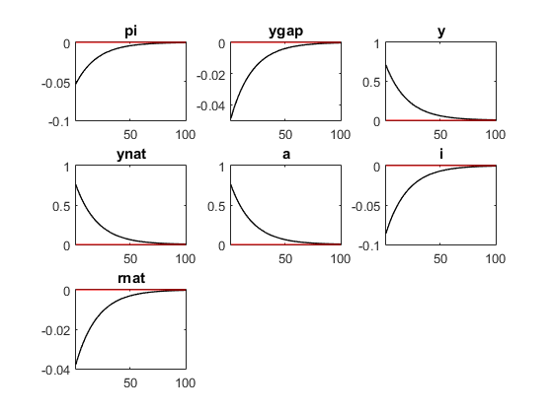

After a technological shock occurs to the system through the standard deviation shock to technology, we can see that first, the value for technology increases by 0.75 due to this shock from epsa. Due to the highly persistent nature of technology as outlined in the description of the model, it takes over 50 periods for all of the relevant variables above to return to their respective steady states of 0. We can also see here that the movement of technology, output and the natural rate of output are all similar as they increase by the same amount and fall in the same time span. In addition, we also see that the nominal interest rate and natural real rate of interest fall, with the nominal interest rate falling more due to the decrease in the natural rate of output. Since we have that the nominal interest rate is a function of inflation and the natural rate of output, we can expect that as both inflation and the natural rate of output decrease so will the nominal rate of interest by virtue of the Taylor rule.

Case 2: An interest rate shock by the central bank

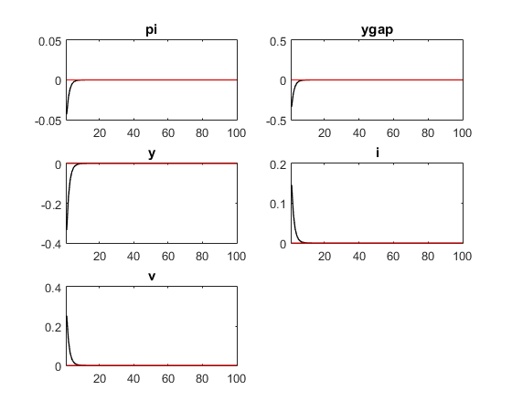

Compared with the previous case, we can clearly see there are striking differences in the time it takes for the variables to return to their steady state values. As previously mentioned, the reason that these variables return to their respective steady states in less than 20 periods, whereas the variables in the previous case took over 50 periods to return to their steady state, is due to the persistence of the interest rate shock. Since we have that rhov is equal to 0.5, the interest rate shock is less persistent and therefore, this shock will tend to dissipate relatively faster than the technological shock which had rhoa equal to 0.95. The immediate effect is an increase in the interest rate shock by a value of 0.25. Here we can see that following the shock we have an increase in the nominal interest rate which is to be expected. We can also see a rather large decrease in the deviation of output from its natural rate likely due to the decrease that we see in output. In addition we can see that inflation also has a minor initial decrease following this interest rate shock.

**Table for Second Moments of Main Variables:**

|  |  |  |  |
| --- | --- | --- | --- |
| Variable | Definition | Variance: Case 1 | Variance: Case 2 |
| ygap | Output Gap | 0.012118 | 0.154801 |
| pi | Inflation (NKPC) | 0.014364 | 0.002547 |
| y | Output at time t | 2.539426 | 0.154801 |
| ynat | Natural Level of Output | 2.902388 | 0.000000 |
| a | Technology | 2.902388 | 0.000000 |
| rnat | Natural Real Interest Rate | 0.007256 | 0.000000 |
| i | Nominal Interest Rate | 0.037456 | 0.029408 |
| v | Interest Rate Shock | 0.000000 | 0.087838 |

Case 1: A technological shock occurs

From the table we can see that in the first case when a technological shock occurs there is no deviation in the interest rate shock which is to be expected. The highest variability that results from this technological shock is in both the level of technology and the natural rate of output. This is an intuitive result as the shock to technology will have a large effect on the variability in the level of technology and in turn the natural rate of output through the natural rate of output equation. We can also see that the output at time t also has a relatively high variability, though it is lower than technology and the natural rate of output. In addition, we can see that the variance is quite low for the output gap, inflation rate, natural real interest rate and the nominal interest rate. Since the output and the natural rate of output are moving in a similar manner this is likely the reason why the output gap has a low variability. Finally, since the shock to technology would not have a large impact on the inflation rate, the natural real interest rate and the nominal interest rate, we can expect the variance for these variables also to be quite low.

Case 2: An interest rate shock by the central bank

From the table we can see that in the second case when an interest rate shock occurs there is no deviation in the natural rate of output, technology or the natural real interest rate. In addition, the highest variability is seen in the output gap and the output at time t. Since these two variables follow a similar path following the interest rate shock, it is intuitive for them to have similar variances. In addition, the interest rate shock had a higher variance than both the nominal interest rate and the inflation rate. This is to be expected since the shock is primarily channeled through the interest rate shock, however it is interesting that the variance of output and the output gap are both larger than the variance of the interest rate shock. From the impulse response functions above, we can see a greater absolute initial change in output and the output gap which is likely why we see their variance to be larger than the variance of the interest rate shock.

**Question 3)**

**Description of the model:**

The model for question three involves 9 endogenous variables and 9 equations with shocks to the interest rate and technology that follow an i.i.d. process. The model is calibrated with the baseline values as specified in the model. There are also 5 internal parameters as specified in the question. This model’s main difference from the others that we have observed so far is the introduction of real marginal cost and output persistence. Due to the introduction of real marginal cost, the form of the New Keynesian Phillips Curve is altered so as to include the past period’s inflation rate as well as the real marginal cost. In addition, the real marginal cost is a function of the output gap in the current period and the previous period. The current period’s natural rate of output is now a function of the previous period’s natural rate of output as well as the current period’s technology. The dynamic IS curve is similar to those utilized previously, however now it is also a function of the previous period’s output gap. Moreover, the natural real interest rate also is slightly altered as it is now a function of the change in the natural rate of output from period t+1 to period t as well as the change in the natural rate of output from period t to period t-1.

**Code of the model:**

// Endogenous Variables

var pi mc y yt yn a i v rn;

// Exogenous Variables

varexo ea ev;

// Parameters

parameters alpha beta sigma phi eps theta rhoa rhov fipi fiy sigmaa sigmav h X omega bigt lambda gammaf gammab;

alpha = 0.33;

beta = 0.99;

sigma = 1;

phi = 1;

eps = 6;

theta = 0.75;

rhoa = 0.95;

rhov = 0.5;

fipi = 1.5;

fiy = 0.125;

sigmaa = 0.75;

sigmav = 0.5;

h = 0.5;

X = 1/(1+h);

omega = 0.5;

bigt = (1-alpha)/(1-alpha+alpha*eps);

lambda = (1-theta)*(1-beta*theta)/(theta*(1+theta*beta*omega))*bigt;

gammaf = beta/(1+theta*beta*omega);

gammab = omega/(1+theta*beta*omega);

//Equations

model;

pi = gammaf*pi(+1) + gammab*pi(-1) + lambda*mc/((1-h)*(1-alpha));

mc = (sigma*(1-alpha) + (alpha+phi)*(1-h))/((1-h)*(1-alpha))*y - (sigma*h*y(-1))/(1-h);

y = yt - yn;

yn = (sigma*h*(1-alpha))/(sigma*(1-alpha)+(alpha+phi)*(1-h))*yn(-1) - ((1-h)*(1+phi))/(sigma*(1-alpha)+(alpha+phi)*(1-h))*a;

a = rhoa*a(-1)+ea;

y = (1-X)*y(-1) + X*y(+1)-((1/sigma)*(1-h)*(i-pi(+1)-rn))/(1+h);

i = fipi*pi + fiy*y + v;

v = rhov*v(-1) + ev;

rn = sigma/(1-h)*(yn(+1)-(yn)) -sigma*h/(1-h)*(yn-yn(-1));

end;

// Steady State

steady;

// Blanchard-Kahn conditions

check;

// Perturbation analysis

shocks;

//1. A Technological shock occurs

var ea; stderr sigmaa;

//2. An interest rate shock by the central bank

//var ev; stderr sigmav;

end;

// Stochastic simulation

stoch_simul (order=1, irf=100, periods = 250);

**Impulse response analysis of main variables:**

Case 1: A Technological shock occurs

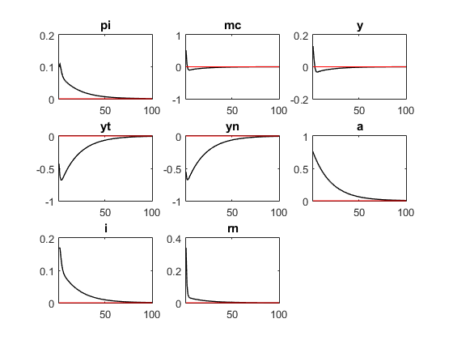

After a technological shock occurs to the system through the standard deviation shock to technology, this leads to the value of technology to immediately increase by 0.75 as seen in the impulse response functions above. As we have previously seen, since technology is highly persistent (rhoa equal to 0.95) we can expect this shock to take a relatively long time to pass through the system. In this way, we can see that it takes over 50 periods before many of the main variables to return to their respective steady states. Following the shock to technology, we can see that the real marginal cost also increases as the current rate of output is larger than the natural rate of output following the shock. Due to this effect, we can expect the output gap to be positive as seen in the impulse response function for y. Since we have this positive output gap and the real marginal cost is positively increasing with the current output gap, we expect the real marginal cost to increase as seen in the impulse response functions. This persistence in the output gap leads the real marginal cost to follow a similar pattern to the output gap as it falls from a positive value to a negative value before converging back to the steady state at 0. In addition, we can see that the nominal interest rate, natural real interest rate and inflation rate all increase before falling and converging back to their steady states.

Case 2: An interest rate shock by the central bank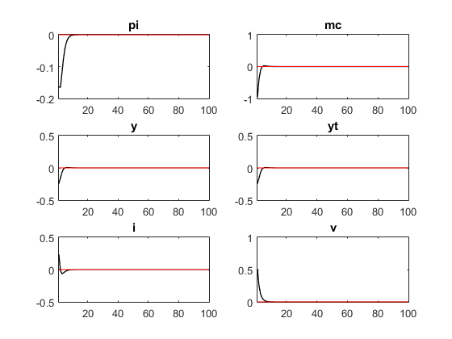

Compared with the previous case we can once more see the striking difference in the time span it takes for the variables to reach their respective steady states. Once more, since we have that rhov is equal to 0.5 whereas rhoa was equal to 0.95 we can expect that the interest rate shock by the central bank will be less persistent and thus, dissipate relatively faster. From the above impulse response functions we can see that the output and output gap both experience an initial decrease before returning to their respective steady states. This differs from the previous example as in this case, there is no deviation in the natural rate of output and thus, the output and output gap follow an identical path. We also see that the interest rate shock increases due to the shock to the system. In addition, we see that the inflation rate and real marginal cost decrease initially before returning to their respective steady states. Since the output gap initially decreases and the real marginal cost is positively related to the current output gap, we can expect the real marginal cost to decrease initially which is what we see in the impulse response functions. Lastly, we have that the nominal interest rate initially experiences a positive increase then falls to a negative value before converging back to the steady state.

**Table for Second Moments of Main Variables:**

|  |  |  |  |
| --- | --- | --- | --- |
| Variable | Definition | Variance: Case 1 | Variance: Case 2 |
| y | Output Gap | 0.025329 | 0.078423 |
| pi | Inflation (NKPC) | 0.043599 | 0.063076 |
| yt | Output at time t | 2.845326 | 0.078423 |
| yn | Natural Level of Output | 2.758365 | 0.000000 |
| a | Technology | 2.902388 | 0.000000 |
| rn | Natural Real Interest Rate | 0.116219 | 0.000000 |
| i | Nominal Interest Rate | 0.099936 | 0.059460 |
| v | Interest Rate Shock | 0.000000 | 0.294711 |
| mc | Real marginal cost | 0.323187 | 0.985475 |

Case 1: A technological shock occurs

From the table above we can see that the variables with the highest variance are output, the natural rate of output and technology. This is intuitive as we can see that the shock to technology will have the largest effect on the current rate of output and the natural rate of output from the impulse response functions seen above. Unlike the previous question, the variance for technology and the natural rate are different now due to the imposition of output persistence. We can also see that since real marginal cost is a function of the current output gap and the previous period’s output gap, it will have the next highest variance since the variance for the output gap is relatively high. The rest of the variables all have a relatively low variance with the interest rate shock obviously being zero in this case.

Case 2: An interest rate shock by the central bank

From the table we can see that the highest variance is seen in the real marginal marginal cost. This is most likely due to the fact that the output gap has a relatively large decrease and since we have that the real marginal cost is a function of the output gap, we can expect it to have a large effect on the real marginal cost. There are three variables here that have zero variance which are the natural rate of output, the natural real interest rate and technology. Due to the natural rate of output having no variance following the interest rate shock, it is intuitive that the output gap and the current output have an identical variance. The second highest variance can be seen in the interest rate shock which is obvious since that is the primary channel through which the shock is occurring. Lastly, we have that the variance of the inflation rate and nominal interest rate are both relatively low.